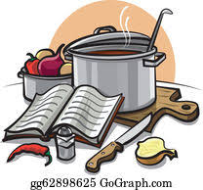
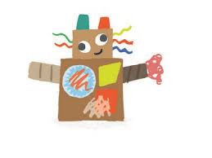
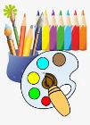
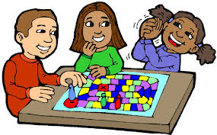
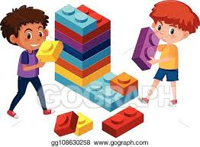
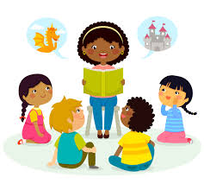
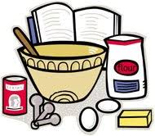
STMP Half Term Bingo
Home Learning Activities
As well as doing some daily exercise, choose one activity to complete each week
Baking  Work with a member of your family to bake some cakes or biscuits. | Story Time  Get comfy and listen to a story.  https://stories.audible.com/discovery | Geography  Create a quiz about about countries, cities and continents. Choose up to 10 questions for example; Which continent is Spain a part of? The answer would be Europe. | Sports  Create a game to play outside with a member of your family. | Drawing  Draw a picture of your favourite memory. What about that memory is beautiful? What makes you remember it? Include all the details in your drawing.
Junk Modelling  Use empty packaging and boxes to create a model of your choice. | Music  Create your own musical instrument. It could be a drum for example made out of cardboard. | Healthy Eating  Create a healthy snack plate with your family. | Chores  Help your adults with some tidying and cleaning. | Map Work  Create a treasure map.
P4C  ‘The best things in life are free’  Do you agree? Explain why to someone at home and ask them their opinion on the statement. | Art  Research ‘Picasso’ and re-create a piece of his art using his particular techniques. | Treasure Map  Create your very own treasure map. | Letter Writing  Write a thank you letter to someone in the community who you think is a hero. | Mary Seacole  Create a fact file about Mary Seacole. Who was she? Why is she an important part of our history? What are the similarities and differences between her and Florence Nightingale?
