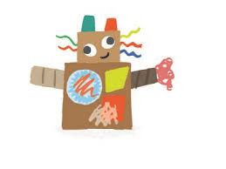
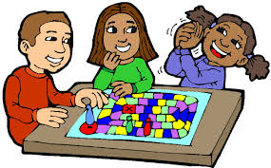
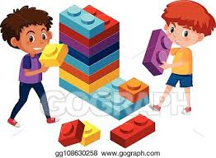
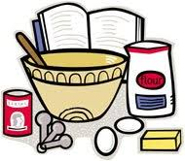
STMP Week 1 Summer 2 Year 2
Bingo
Home Learning Activities
As well as doing some daily exercise, choose one activity to complete each day…
Mathematics  Create a pattern with shapes. For example; | Story Time  Listen to the following story:  https://www.youtube.com/watch?v=CFq441el_ls  Create a quiz for someone at home to answer once they’ve watched the story. | Construction  Use cardboard boxes to make a hospital for Florence Nightingale. Remember to include the important things for example; beds, sinks, toilets and cleaning products | Times Tables  Write as many times tables as you can for the 2, 5 and 10 times table. Do you know your division number sentences too? Have a go! | Art  Collect flowers and outdoor nature items to create a unique picture.
Science  https://www.bbc.co.uk/bitesize/clips/z3mb9qt  Write the definition for ‘light’. | Music  Use the internet to explore the artist ‘Mozart’. Draw a picture when listening to one of his songs and describe how it makes you feel. | Cooking  Ask an adult at home to help you prepare a healthy lunch or dinner. Remember to include fruit and vegetables. | History  Research Mary Seacole. Write down five or more facts you have found about her that you would like people to know. | Map Work  Create a map from your house to school or from your house to the local park or shops. Make it as colourful and bright as you can.
Geography  Learn your address by heart. Draw a picture of your house and write the address underneath. Remember not to tell anyone your address, only in an emergency. | Instruction Writing  Write a set of instructions to do something using bossy verbs such as; put, pour, mix, stick. | Spelling  Practise spelling these words using look, cover, say, write, check.  door, floor, poor, mind, behind, child, find, children, behind, because. | English  Write a letter to a friend that you miss. Talk about your favourite activities and what it is about them you enjoy. | Maths  Find things in your house that you think are larger than 1 metre. Draw them and for an extra challenge, estimate their measurements for example; door 1m 57cm.
